To create your character you need to follow the steps below:

First, create the concept. Create your character. For an example I will generate a character.

My character is a Male human, he is a traditional medieval adventurer. He has a longsword and some middleweight armor. He is somewhat athletic. He spends his time on the road and on the big cities. He earns money through dirty stuff, basically a sword for hire. He is like Bronn from Game of Thrones



He is human, he fights, he is a little bit sneaky, doesnt have much charisma and the brains but has the wits.

Lets start the process

**1. Choose a Race:**

Choose any race you want for your needs, some races have bonuses to their stats, and to balance their bonuses, they have also some penalties. For ex: +2 dex and -2 con for elves

I chose human for +1 bonus feat for the first level and it comes handy for your build in mind.

**2. Select a Class:**

Choose any race that has the abilities you want. Some classes are combat oriented, some are more like utility classes, some are jack of all trades.

**Hit Points (HP):** Determines your character's health.

**Base Attack Bonus (BAB):** Measures your combat prowess.

**Saves:** Reflects your character's ability to resist various dangers. You use save throws to negate some spell, trap, poison effects. There are 3 saves, Reflex (Dex) for dodging traps, Fortitude (Con) to deal with poisoning, or resisting stuff, Will (Wis) to resist mind effects, fear and such

**Class Skills:** Skills your character is good at. There are tons of skills but you have certain numbers of skill points. Just select a few you think important. Only some specified or knowledge and profession skills cannot be used without spending points in them

**Skill Points:** Points used to improve skills. Every class has a certain numbers of skill points

**Feats:** Bonus abilities or skills you can choose. This is where you customize your character’s way of dealing with stuff

**Special Abilities:** Unique powers or spells specific to your class. This comes with leveling

**Class Features:** Class-specific skills and abilities, like a wizard's spells, a rogue's sneak attack, or a cleric's healing. This comes with leveling  
  
For my example I choose the Ranger class

I also use a City ranger variation.

Rangers also have “Favored Enemy” special ability. You choose one enemy type to gain advantages on them. I choose Humans for this one.

Rangers also has good skills to use for survival and decent starting skillpoints. But the alternate City Ranger version has city oriented skills for them.

**3. Pick Feats:**

For feats, I choose Weap. Focus (longsword) , Power attack

**4. Equip Your Character:**

Determine the weapon, armor, equipment you have.

I choose a longsword and half plate armor and a shield. Also some adventuring kit.

This section should be determined with the dm.

And that is it. If you are a spellcaster, you also have to choose spells. Just browse some spells and choose which ones you want.

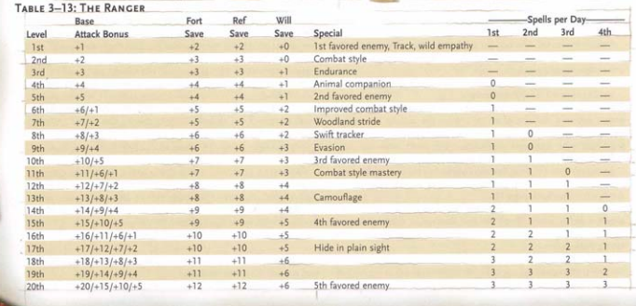

Fill the character sheet with whats on the table and you are good to go.

At first level, Ranger has 1 Base attack bonus, +2 fort +2 ref saves and three special features.